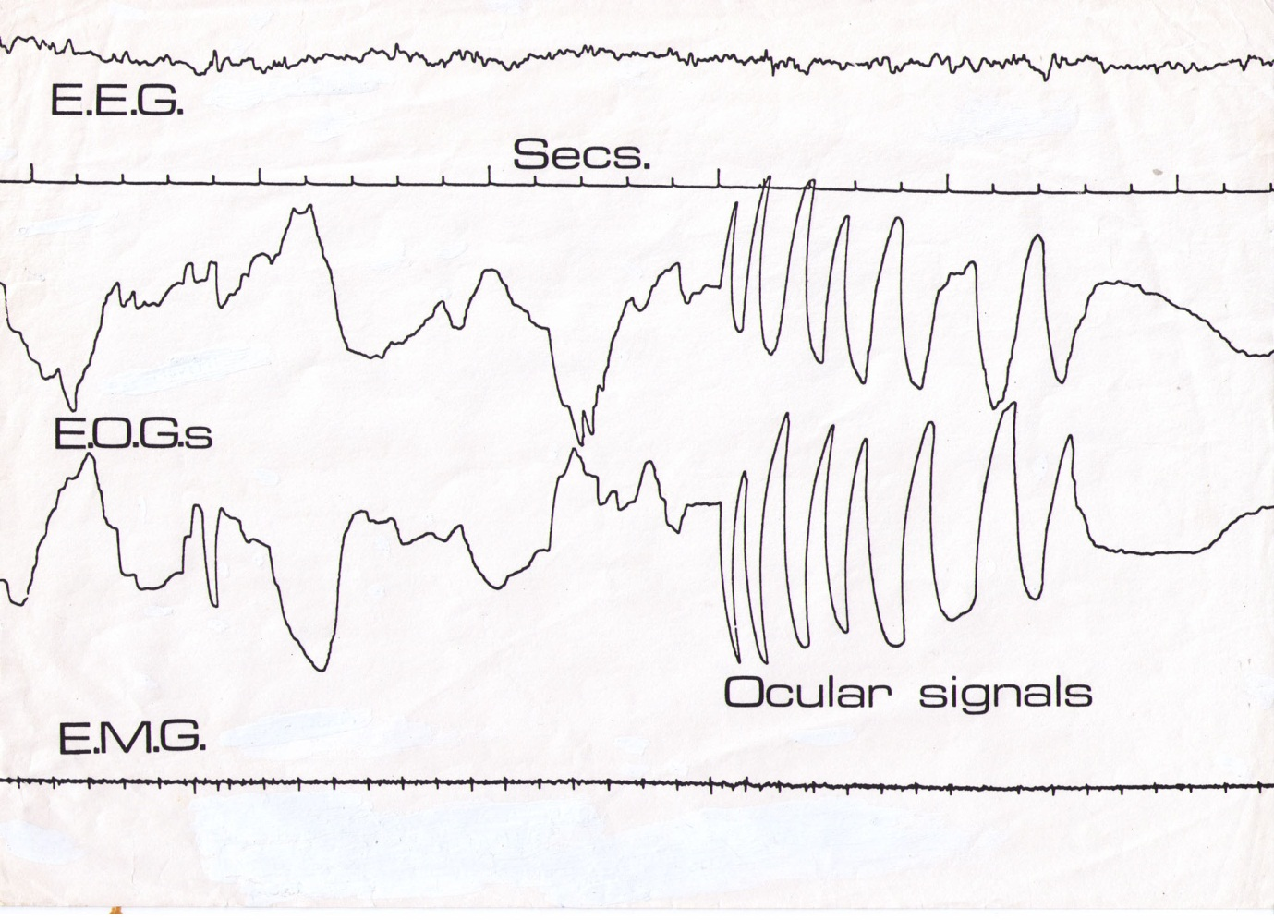
A sequence of left/right ocular signals, recorded at Liverpool University (UK) using a Grass polygraph. Note the pre-lucid REM (Rapid Eye-Movement) burst preceding the signals. This consistent effect was discovered by Hearne.
EEG - Electro-encephalograph (brain-waves trace)
EOG - Electro-oculograph (eye-movement trace)
EMG – Elecro-myograph (muscle activity trace)

